**Introduction to the Linear/Polynomial** **Regression Program (LPR)**

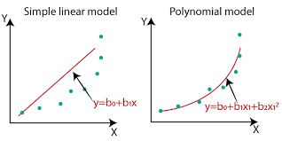

**I**

Steven H. Stein

**ntroduction**

In statistical modeling, regression analysis is a set of statistical processes for estimating the relationships between a dependent variable and one or more independent variables. The most common forms of regression analysis are linear or polynomial, in which one finds the line/curve that closely fits the data.

Regression analysis is primarily used for two purposes:

1. Prediction and forecasting;

2. Causal relationships between independent & dependent variables, typically called X and Y variables.

**P**

**rogram Description**

This program performs either a linear or a polynomial regression on a given data set of dependent and independent variables. The following is an outline of the program:

*Outline of the Linear/Polynomial Regression Program (LPR)*

1. Select Linear, Polynomial Regression, or consecutive Degrees of Freedom Regressions
2. Input X/Y datasets [Manual or Import from file]
3. Perform regression analysis
4. Show correlation results (Correlation Coefficients) and regression equation
5. Show graph plot of datasets and the regression equation (optional, capture/save plot)
6. Generate files the following files: DATA, LPR, YCAL, SPLT
7. DATA - regression equation and Coefficients of Correlation and Determination
8. LPR - alternate regression equation and Correlation Coefficients for reference
9. YCAL - calculated Y value for a given X value
10. SPLT - code to create a graph of X/Y datasets

**Note:** The program can also create a directory for each of these files and directory to place X/Y datasets files to be imported.

1. Option, calculate a Y value for a X value

The program will also check Input values for certain errors, e.g., entering a non-numeric character where a number is required. Error correction is available in case an input entry was entered incorrectly.

This program was written and compiled using Microsoft Quick Basic 4.5 in a Windows 11 environment. In order to run the program, a DOS emulation program must be installed and the regression program runs inside it.

The following is a screenshot of the Main Menu:

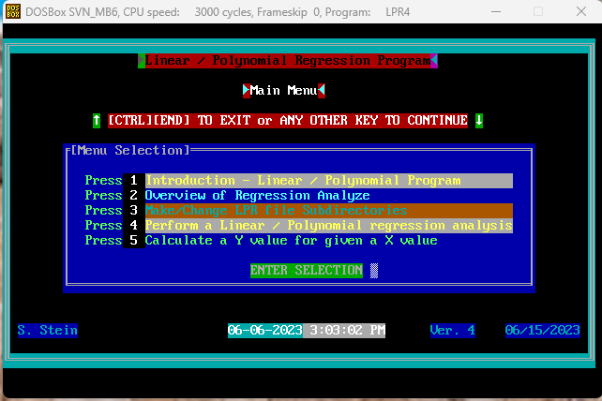

**Note:** In the upper left corner, the LPR4 program running inside DOSBox!

The required files are included in two zip files (LPR4. Zip and DOSBox Megabuild 6.dmg.zip), as well supporting programs listed in the following table.

The following Table lists the programs that were use to support the creation of the LPR program.

|  |  |  |  |  |
| --- | --- | --- | --- | --- |
| **Program Name** | **Author** | | **Description/Function** | **Download File Name** |
| Quick Basic 4.5 | | Microsoft | QuickBASIC provides a programming platform to write a program be entering “code” (sequences of QuickBASIC statements) that describe what the program is to do. | QB45.zip |
| ADVBAS v99, 04/02/88 | | Thomas Hanlin III | ADVBAS provides a number of assembly language routines which perform various functions, and puts them in a library which the compiler can access. For example, the MAKEWINDOW routine Creates a pop-up window on the screen. | ADVBAS.zip |
| SPLOT  Ver. Number: 7.61  (PLOTDUMP) | | William G. Hood | SPLOT (Screen PLOT) will plot two and three dimensional data. The SPLOT program creates a plot by executing a sequence of plot commands. The memory resident program PLOTDUMP (which comes with the SPLOT software) outputs the plot to a number of options, e.g., a printer or a pdf file. | Included in LPR4. zip |
| QUIKCODE | | James K. Fugate | QUIKCODE enables screen designs to be created and saved as a file. It has created files that can be restored to the monitor to serve as an introductory screen, a menu, or a data entry screen. (These screen files have the following file names: LR.0xx or LPR.xxx)  **Note:** The program was modified to allow screen borders, text and special characters to be in color, where the original program only allowed white. | SD1.zip  **Note:** The program can’t run in Microsoft Quick Basic 4.5. A copy of Microsoft gwbasic is included in the zip file to run the program. |
| DOSBox Megabuild6 | | Peter Veenstra and Crew | DOSBox is a DOS-emulator that is needed to run the LPR program. LPR can’t run in a Windows environment. | DOSBox Megabuild 6.dmg.zip |
| Filer46 | | Robert Goddard | This program is one of the options available to import an X/Y dataset. | Filemenu.exe/ Filemenu.bas |
| HMenu  March 2002 | | Ray Thomas | This program is another one of the options available to import an X/Y dataset. It can also be used to perform various file management functions such as coping files or creating directories. | DSXYMENU.exe/ DSXYMENU.bas |
| Source Code | | Steve Stein | The LPR4 program and all modules that are invoked with the Shell command written in Quick Basic 4.5. | SC.zip |

**Note:** As noted in this Table, you can make your own changes using the source codes provided.

**I**

**nstallation**

**Step 1** Download the following two zip files

1. LPR4. zip
2. DOSBox Megabuild 6.dmg.zip

**Step 2** Install the DOSBox program to any directory. It is recommended that the configuration file be modified to facilitate running the LPR4 program. This will typically require adding the following to the end of the configuration file:

MOUNT C C:\

C:

CD C:\LPR4

Plotdump /ph

LPR4

**Note:** Refer to the DOSBox Manual.htm file (included in the DOSBox Megabuild 6.dmg.zip) for more details.

**Step 3** Create a directory for the LPR4 program files. It is recommended that it be C:\LPR4, as noted Step 2. Unzip the LPR4. Zip file into the directory.

**Step 4** Start the DOSBox Megabuild 6 program. If you have edited the configuration file, the program will start.

If the configuration file has not been edited, then you will need to navigate to the LPR4 directory. Then, enter the two following commands:

Plotdump /ph

LPR4

**Step 5** It is recommended that directories for the DATA, LPR, YCAL, SPLT (and one for X/Y dataset files) files be created before running any regression analyses.

**Note:** For assistance, send an email to: [shsrms@gmail.com](mailto:shsrms@gmail.com)